CHLEBA SE SÁDLEM A cIBULÍ
Slice of bread with lard and chopped onion

20,- Kč
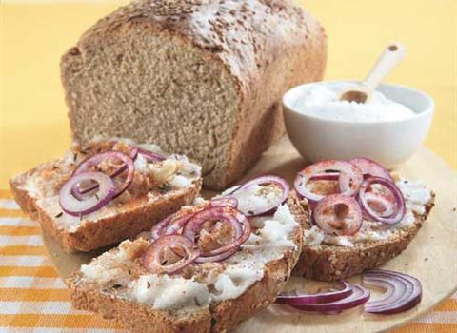

CHLEBA SE ŠKVARKOVOU POMAZÁNKOU
Slice of bread with greaves spread

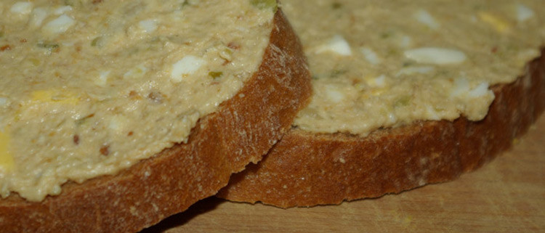
25,- Kč

